an **Ansible POC (Documentation)**

**Server (Controller) Setup on red hat Linux** [**https://www.youtube.com/watch?v=DZ84onseKek**](https://www.youtube.com/watch?v=DZ84onseKek)

1. Launch EC2 Instances From AWS Console.
2. Connect those instances using putty
3. Set Hostname for both servers

Hostname for Ansible controller(Linux): Server

**Vim /etc/hostname**

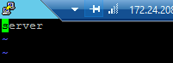

**Ansible Installation on server:-**

Adding RPM package to repo

1.rpm –Uvh <https://dl.fedoraproject.org/pub/epel/epel-release-latest-7.noarch.rpm>

2.yum install -y Ansible

Creating SSH Keys on server (controller)

1.**ssh-keygen –t rsa ---**command to generate ssh keys

2. **cd /root/.ssh** ---- keys location server

3. **cat id_rsa.pub** and copy the content



**Configuring Ansible agent(Node):**

**Setup hostname:**

1.Hostname for Ansible Agent(Amazon machine image Linux): Client

**vim /etc/sysconfig/network –**location to change hostname

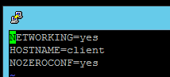

2.copy public key (**id_rsa.pub**) from controller(Ansible where we installed) and paste at nodes **vim /root/.ssh/authorized_keys**

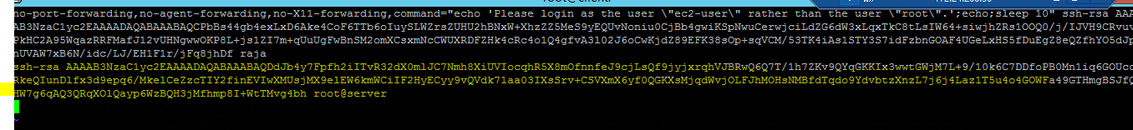

**3.**Now we have to enable PermitRootLogin in **vim /etc/ssh/sshd_config**

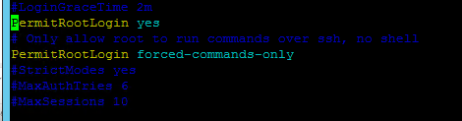

4.Restart the sshd service **/etc/init.d/sshd restart**

**5.**Add Hostname in **vim /etc/hosts** file

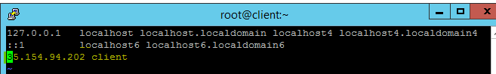

**Server side:**

**1.**Add client Hostname and public ip in **vim /etc/hosts**



Now we can check connection between server(controller) and client using below commands

1. **ssh client** (from server)

then enter **yes** now u are in client server

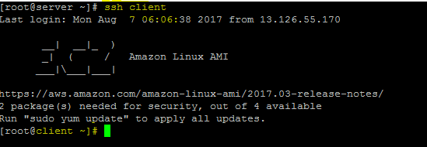

Now we are going to configure client to Ansible server

1. Add Client hostname at **vim /etc/Ansible/hosts** file



**2.**Check the Ansible connection is reachable to server and client using below command

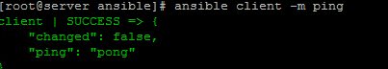

**----Windows Agent Configuration-------**

Ansible Windows client configuration:

1. Create windows. Yml file at \etc\ansible\group_vars(at Ansible controller)
2. Mention windows agent credentials (at Ansible controller)

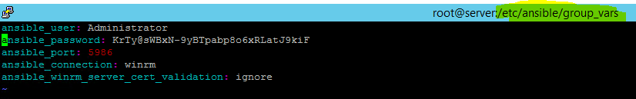

4.Mention windows agent ip address at Ansible host file(Ansible controller server)

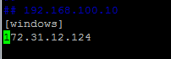

3.Now we have to enable the Winrm service (on windows agent)

For this we have to run the powershell script

Download <https://github.com/ansible/ansible/blob/devel/examples/scripts/ConfigureRemotingForAnsible.ps1>

And run the ConfigureRemotingForAnsible.ps1 on windows Agent

Now check with below command on Ansible controller

ansible windows -vvv -i hosts -m win_ping

